# UNEMPLOYMENT ISSUE IN INDIA

**A PROJECT REPORT**

*Submitted for*

**CSE3009 – NoSQL Databases**

*by*

Rasmika Billa (18BCD7021)

Kolluru Sai Venkata Sailesh (18BCD7120)

Fadia Zeel Kaushal (18BCD7077)



SCHOOL OF COMPUTER SCIENCE ENGINEERING

VIT-AP UNIVERSITY

AMARAVATI- 522237

*May 2021*

Abstract

The mini project focuses on creating a Java web application to provide effective assistance to people who are unemployed and help them by searching and applying jobs more conveniently and easily. It helps balance work among people as it would solve the major issue in our nation.

The main aim of this project is to help the people who are in a situation where they cannot afford even though they are well educated. At the tough times, such as the pandemic it has become much more tough to find a job and earn a living.

Thus, we have made an application that gives users an easy access to view all the job postings and at the same time companies can access, insert, update and delete their job postings according to availability.

## Table Of Contents

|  |  |  |
| --- | --- | --- |
| **S.no** | **Title** | **Page No.** |
|  | Abstract | 1 |
| 1 | Introduction | 3 |
| 2 | Discussion | 5 |
| 3 | Database Analysis | 8 |
| 4 | Results | 10 |
| 5 | Conclusion & Future Works | 11 |
| 6 | Project Code | 12 |
| 7 | References | 18 |

### Introduction

Unemployment occurs when a person who is actively searching for employment is unable to find work. Unemployment is often used as a measure of the health of the economy. The impact of unemployment is discussed as follows:

* The problem of unemployment gives rise to the **problem of poverty**.
* Young people after a long time of unemployment indulge in illegal and wrong activities for earning money. This also leads to **increase in crime in the country**.
* **Unemployed persons can easily be enticed by antisocial elements.** This makes them lose faith in democratic values of the country.
* It is often seen that unemployed people end up getting addicted to drugs and alcohol or attempts suicide, leading losses to the **human resources of the country**.
* It also affects **economy** of the country as the workforce that could have been gainfully employed to generate resources actually gets dependent on the remaining working population, thus **escalating socioeconomic costs** for the State.

Such problems have led to a major concern especially during the times of pandemic and immediate solution for this problem has become necessary in order to sustain the economic development.

#### Objectives

The following are the objectives of this project:

* Creating an application to provide effective assistance to people in search of work.
* Company registration and Login to make the application secure.
* A company such as a company’s manager can register and operate job listings in the java application.
* Apply Crud operations such as a company can add, update or delete job postings.
* On the other end, a user can view all the companies or any specified company he/she is interested in.

#### Background and Literature Survey

#### Just before the Covid crisis at the end of 2019-20 financial year, India had (according to the data provided by Mahesh Vyas of Centre for Monitoring Indian Economy) around 403.5 million employed people and around 35 million (or 3.5 crore) openly unemployed people in the country.

#### The basis of this project comes for major problems like these. India's unemployment rate rose sharply in December 2020 and touched a six-month high. The fact that the unemployment rate has been rising since September 2020 despite faster recovery has raised concerns. India’s unemployment rate rose sharply to 9.1 per cent in December 2020 even as economic activity continues to increase which is one of the major concern.

#### Organization of the Report

The mini project report is described as follows:

* Introduction: contains the proposed project, objectives and its details.
* Discussion: a detailed explanation and working of the project.
* Database Analysis: going through the database used for the project.
* Results: discusses the results obtained after the project was implemented.
* Scope: concludes the report.
* Project Code: consists of codes implemented in the project.
* References: gives references used for the mini project.

Discussion

The company manager can register on behalf the company by signup and login process for basic security as shown below:

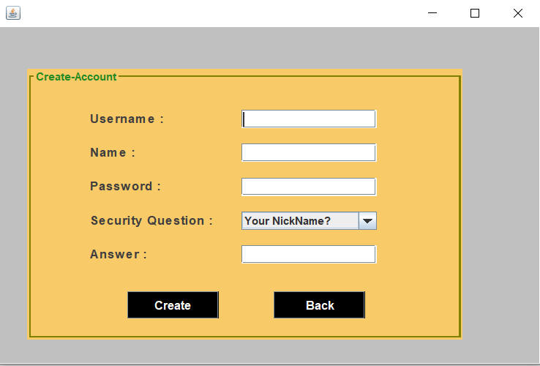

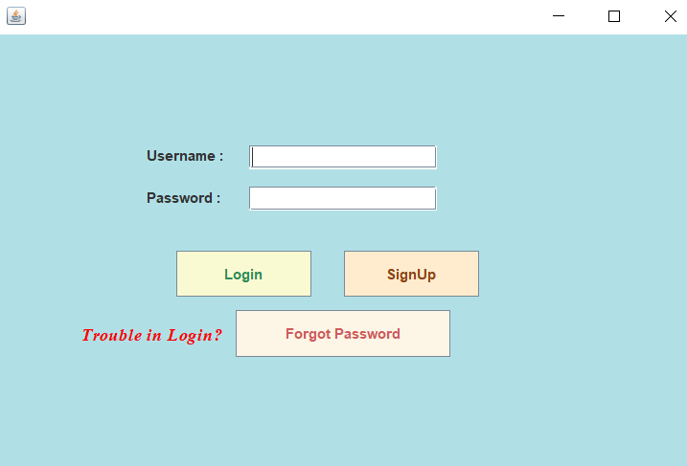

After the registration process, the company can now view all the job postings, edit the job postings and add a post or delete a post.

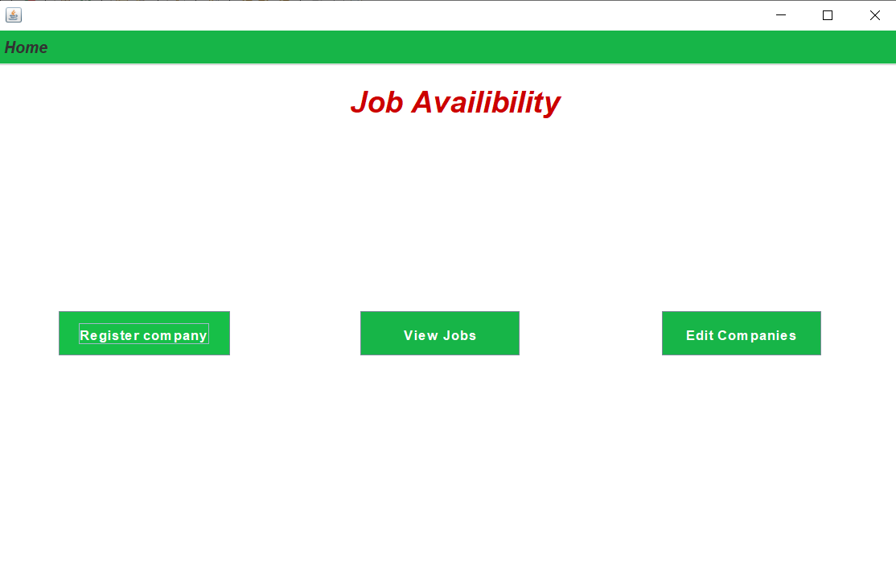

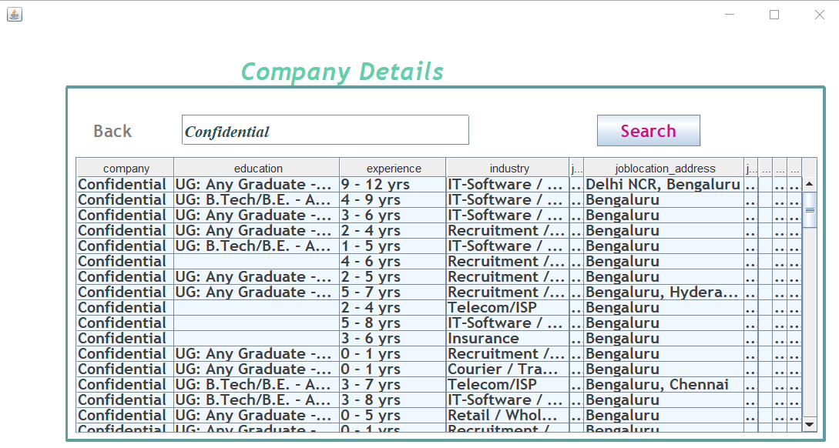

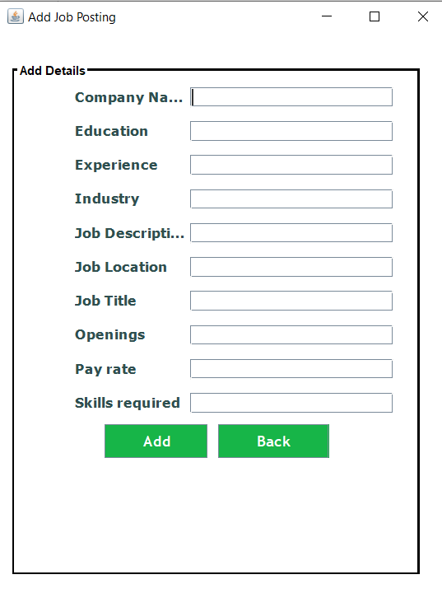

As, we can see in the given pictures the company can do the following operations:

* They can add job postings based on their availability.
* They can make changes to the same job postings in Edit Details column.
* They an delete the job posting after the requirement is fulfilled.
* They can view all their postings as well as see other company too.

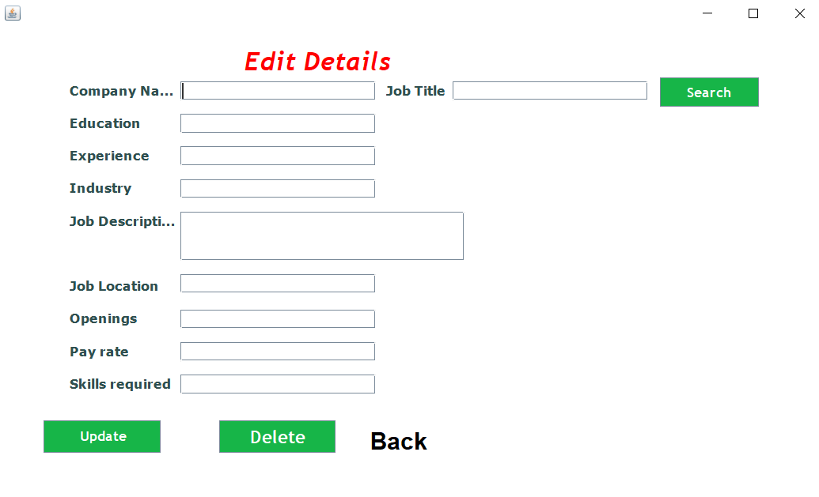

#### Database Analysis

* The database used for this project is MongoDB.
* **It** is a document-oriented NoSQL database used for high volume data storage.
* Instead of using tables and rows as in the traditional relational databases, MongoDB makes use of collections and documents.
* Documents consist of key-value pairs which are the basic unit of data in MongoDB.
* Collections contain sets of documents and function which is the equivalent of relational database tables.
* MongoDB is a database which came into light around the mid-2000s.

In Our Project:

The database name is Nosql.

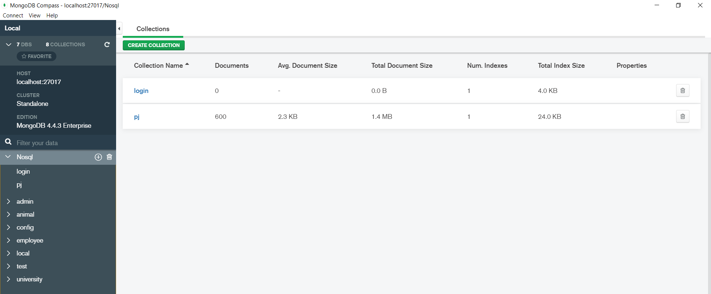

It has two collections namely: login and pj.

* login collection stores details of a company so that whenever a company has to make changes or add job posting, it can be in a more secured manner.
* pj collection stores details of all the job postings of all companies. For now, it has more than 600 documents stored in it.

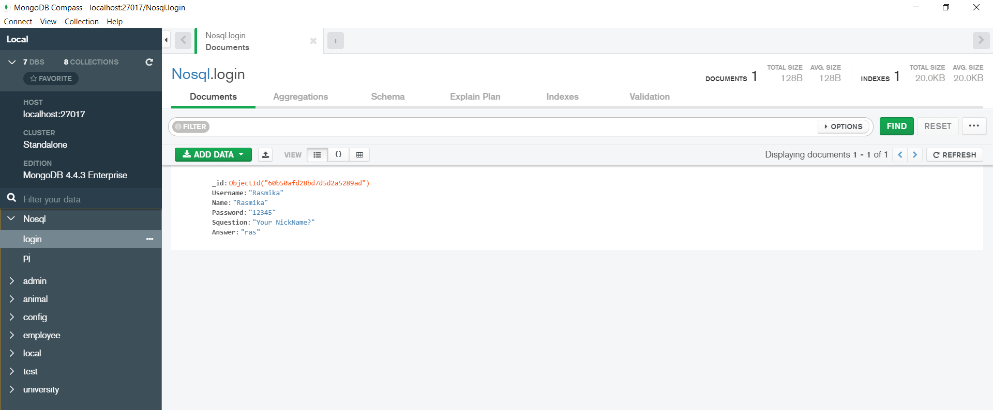

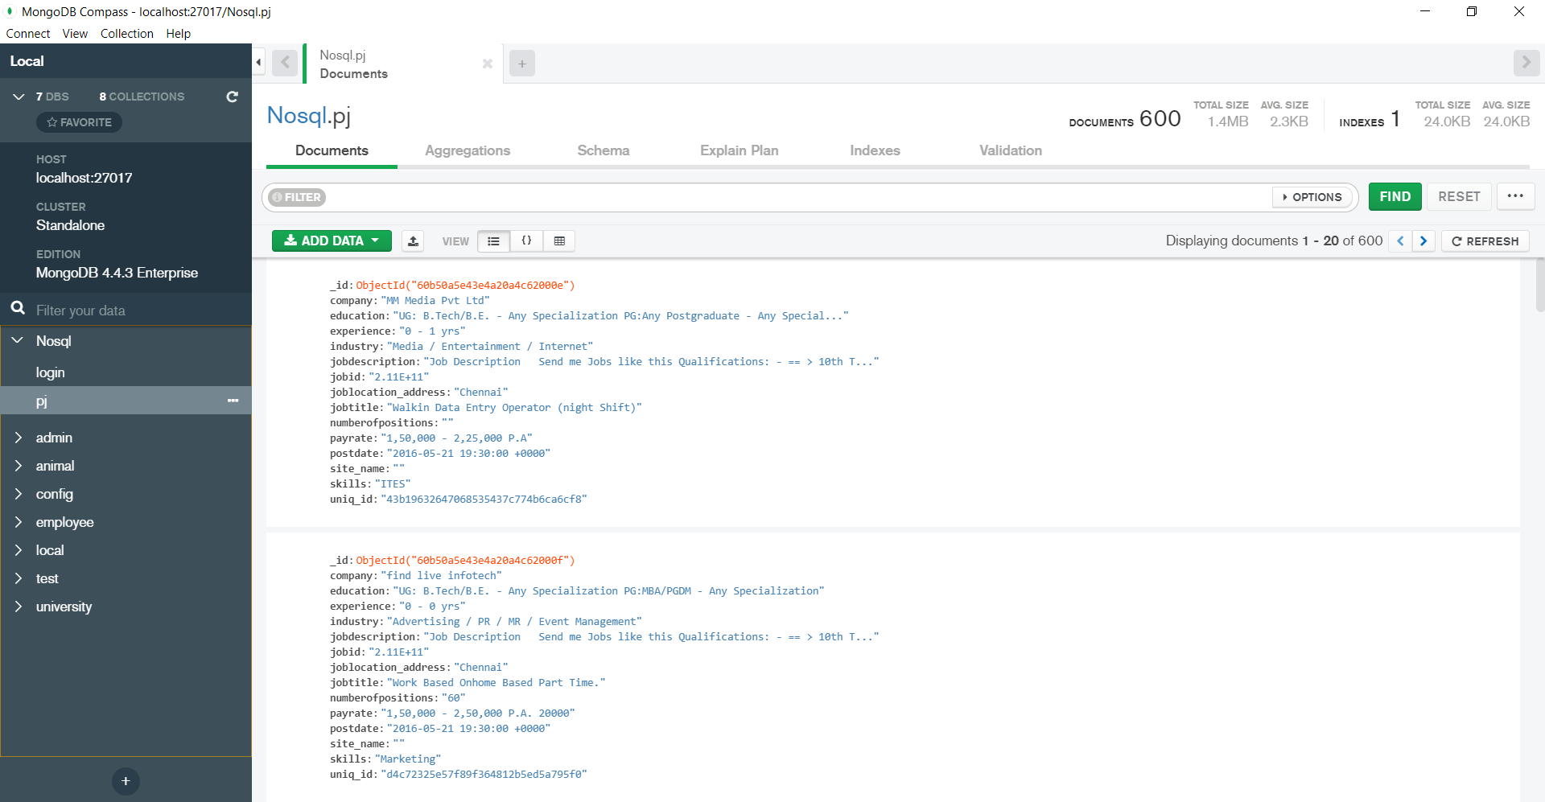

Results

The application consists of a multiple web pages allowing the user to go through all the companies or search for a specific one with a valid company name. When an invalid email address and/or an invalid file is submitted, an error message is displayed.

At the same time, the company manager can register and login on behalf of the company and add, delete or update their companies job postings accordingly in the application so that the user can easily access it and apply for the same.

The mini project abides by the objectives discussed above and completes the entire process with proper work flow in the designated time.

Conclusion and Future Work

This Java web application builds a path to utilize every second to its maximum. It allows the company and the workers to make the necessary arrangements for solving unemployment as far as possible to ensure proper economic growth in India.

The unemployment issue with rising technology, both are open to improvements with huge scopes. Lot can be done in this area. This project can be extended as follows:

* to support people with urgent needs.
* to apply for companies in the same application.
* to ensure proper communication between users and their applied companies.
* to make a portal for both sides i.e., the users and the company holders for better working and efficiency.

Project Code

Conn.util (Connects MongoDB to Java)

package Connection.util;

import com.mongodb.MongoClient;

import com.mongodb.MongoCredential;

import com.mongodb.client.MongoDatabase;

public class Conn {

public static MongoDatabase getConnect(String dbname)

{

MongoClient mongo = new MongoClient("localhost",27017);

MongoCredential credential;

credential = MongoCredential.createCredential("sampleUser","myDb","password".toCharArray());

System.out.println("Connected to the database Successfully");

//Accessing the database

MongoDatabase database=mongo.getDatabase(dbname);

System.out.println("Credentials :: "+credential);

return database;

}

}

Nosqlpj.java

package nosqplpj;

import Connection.util.Conn;

import com.mongodb.client.MongoDatabase;

public class Nosqplpj {

public static void main(String[] args) {

// TODO code application logic here

//Conn c=new Conn();

String s="Nosql";

MongoDatabase database=new Conn().getConnect(s);

new Login().setVisible(true);

}

}

Home.java(where all the java files are executed and operations are performed)

package nosqplpj;

import javax.swing.*;

import java.awt.*;

import java.awt.event.*;

import static java.awt.image.ImageObserver.ABORT;

public class Home extends JFrame implements ActionListener{

private JPanel contentPane;

private JButton b1,b2,b3,b4,b5,b6,b7;

public static void main(String[] args) {

new Home().setVisible(true);

}

public Home() {

setBounds(430, 150, 1030, 700);

contentPane = new JPanel();

setContentPane(contentPane);

contentPane.setLayout(null);

JMenuBar menuBar = new JMenuBar();

menuBar.setBackground(new Color(23, 181, 72));

menuBar.setBounds(0, 0, 1200, 35);

contentPane.add(menuBar);

JMenu mnExit = new JMenu("Come out");

mnExit.setFont(new Font("TimesNewRoman", Font.BOLD |Font.ITALIC, 16));

JMenuItem mntmLogout = new JMenuItem("Logout");

mntmLogout.setBackground(new Color(211, 211, 211));

mntmLogout.setForeground(new Color(105, 105, 105));

mntmLogout.addActionListener(this);

mnExit.add(mntmLogout);

JMenuItem mntmExit = new JMenuItem("Exit");

mntmExit.setForeground(new Color(105, 105, 105));

mntmExit.setBackground(new Color(211, 211, 211));

mntmExit.addActionListener(this);

mnExit.add(mntmExit);

menuBar.add(mnExit);

JLabel l1 = new JLabel("Job Availibility");

l1.setForeground(new Color(204, 0, 0));

l1.setFont(new Font("TimesNewRoman", Font.BOLD|Font.ITALIC, 30));

l1.setBounds(350, 30, 701, 80);

contentPane.add(l1);

b1 = new JButton("Register company");

b1.addActionListener(this);

b1.setBackground(new Color(23, 181, 72));

b1.setFont(new Font("TimesNewRoman", Font.PLAIN | Font.BOLD, 14));

b1.setForeground(Color.WHITE);

b1.setBounds(60, 280, 159, 44);

contentPane.add(b1);

b4 = new JButton("View Jobs");

b4.addActionListener(this);

b4.setBackground(new Color(23, 181, 72));

b4.setFont(new Font("TimesNewRoman", Font.PLAIN | Font.BOLD, 14));

b4.setForeground(Color.WHITE);

b4.setBounds(360, 280, 159, 44);

contentPane.add(b4);

b6 = new JButton("Edit Companies");

b6.addActionListener(this);

b6.setBackground(new Color(23, 181, 72));

b6.setFont(new Font("TimesNewRoman", Font.PLAIN | Font.BOLD, 14));

b6.setForeground(Color.WHITE);

b6.setBounds(660, 280, 159, 44);

contentPane.add(b6);

contentPane.setBackground(Color.WHITE);

}

public void actionPerformed(ActionEvent ae){

String msg = ae.getActionCommand();

if(msg.equals("Logout")){

setVisible(false);

new Login().setVisible(true);

}else if(msg.equals("Exit")){

System.exit(ABORT);

}

if(ae.getSource() == b1){

this.setVisible(false);

new AddCompany().setVisible(true);

}

if(ae.getSource() == b4){

this.setVisible(false);

new CompanyDetails().setVisible(true);

}

if(ae.getSource() == b6){

this.setVisible(false);

new edit_form().setVisible(true);

}

}

}

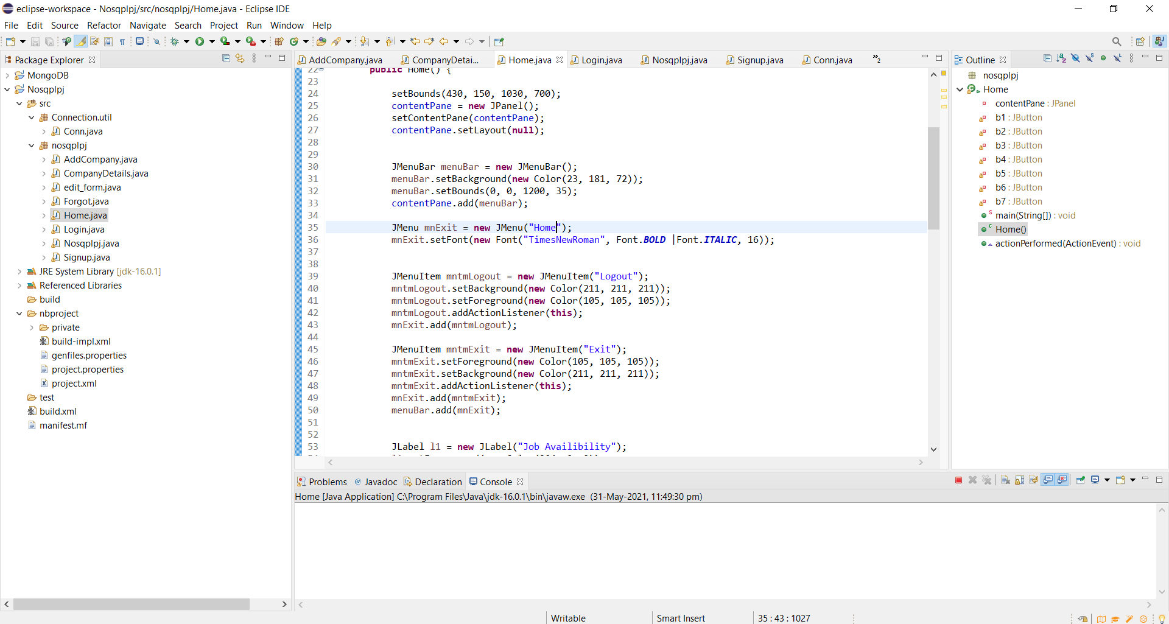

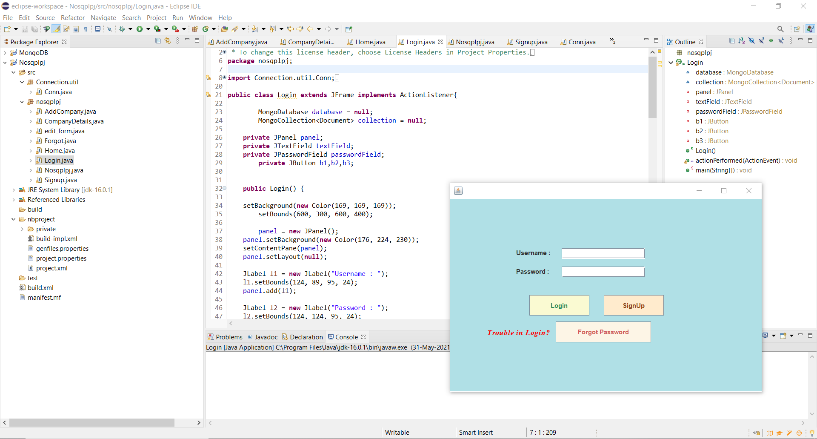

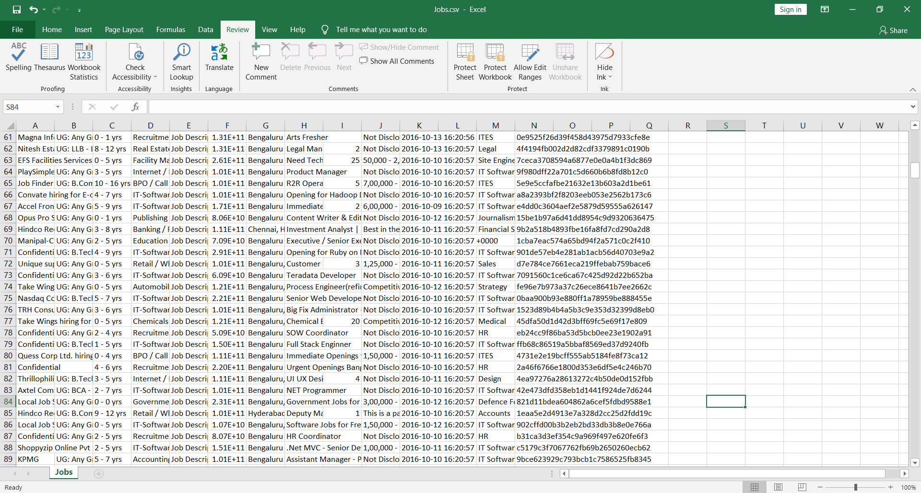

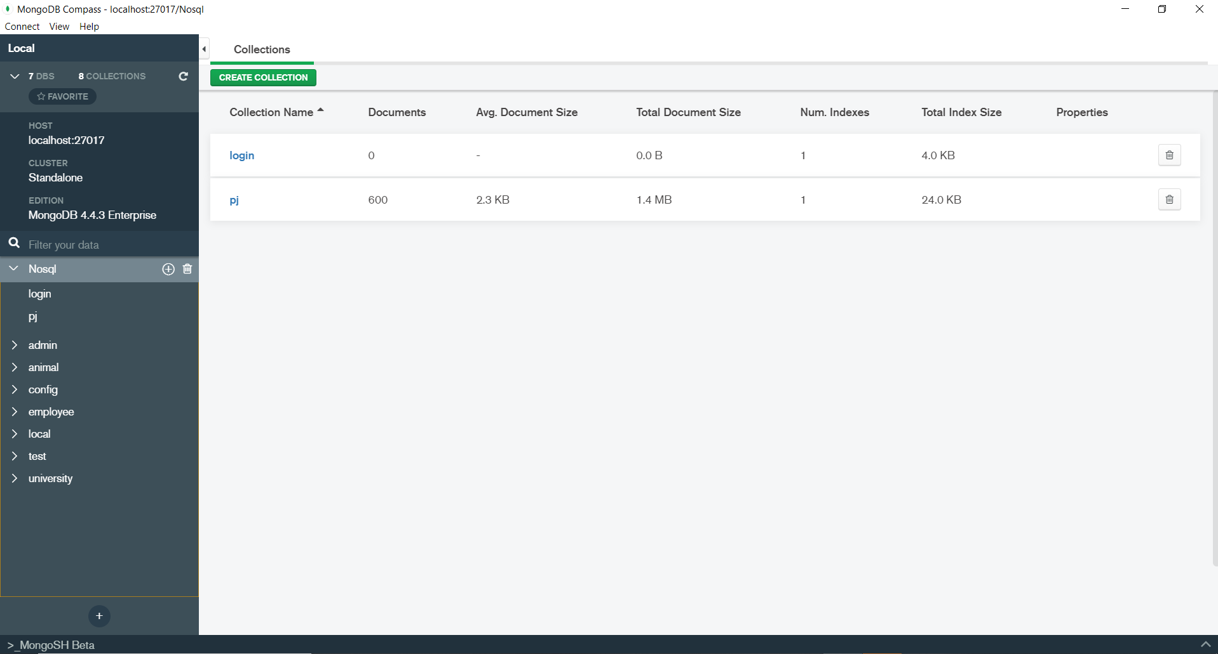

References

* <https://www.guru99.com/what-is-mongodb.html>
* <https://www.tutorialspoint.com/mongodb/mongodb_java.htm>
* <https://www.mongodb.com/java>
* <https://www.baeldung.com/java-mongodb>
* <https://www.drishtiias.com/to-the-points/paper3/unemployment-in-india>
* [https://www-indiatodayin.cdn.ampproject.org/v/s/www.indiatoday.in/amp/ business/story/](https://www-indiatodayin.cdn.ampproject.org/v/s/www.indiatoday.in/amp/%20business/story/)